GRADE 7 ACCELERATED · UNIT 2 · LESSON 3
Cube Values
Additional Practice 7A.02.03 ANSWER KEY

1. Complete the table. Each volume is the side length multiplied by itself three times.
Side s | 1 | 2 | 3 | 4 | 5
Volume s³ | 1 | 8 | 27 | 64 | 125
Side −s | −1 | −2 | −3 | −4 | −5
Volume (−s)³ | −1 | −8 | −27 | −64 | −125

Cubing preserves the sign: positives stay positive, negatives stay negative. Squaring does not.
2. Find the volume of the cube shown.
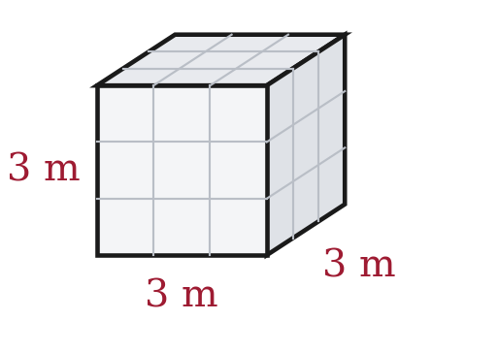
V = 3³ = 3 × 3 × 3 = 27 cubic meters
A student who answers 9 has stopped after squaring.
3. A cube-shaped box has a volume of 8 cubic centimeters. How long is one edge?
2 × 2 × 2 = 8, so each edge is 2 centimeters.
For questions 4 through 7, find the value.
4. 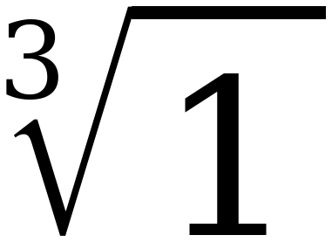
1

5. 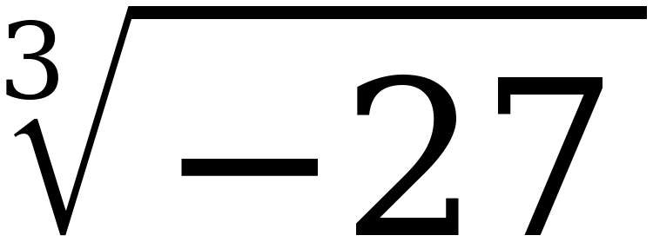
−3 (−3) × (−3) × (−3) = −27
A cube root of a negative number exists. A square root of one does not.

6. 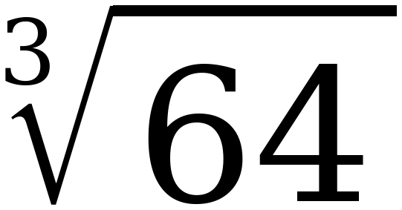
4

7. 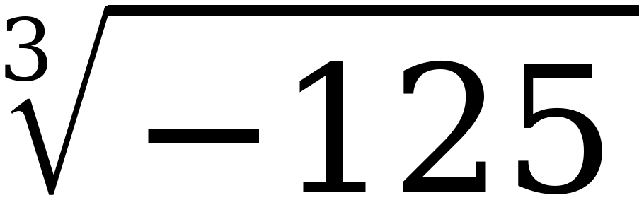
−5

For questions 8 through 10, find every real solution of the equation.
8. x³ = 27
x = 3 one solution, not two
(−3)³ = −27, so −3 does not work.

9. a³ = −8
a = −2

10. w³ = 1
w = 1
Not ±1. (−1)³ = −1.

11. Select ALL of the values below that make x³ = 125 true.
☒ | 5 | ☐ | −5
☒ | 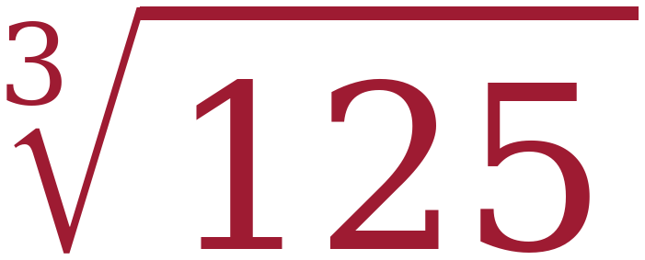 | ☐ | −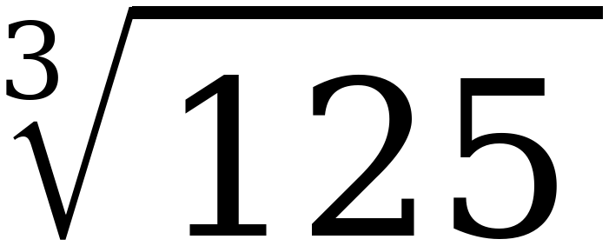
☐ | 25 | ☐ | 41⅔

Two of the six. −5 and −∛125 both give −125. 25 is 5², and 41⅔ is 125 ÷ 3.
12. Complete the table of values for y = x³. Then plot the five points on the grid.
x | Substitute into y = x³ | Coordinates (x, y)
−2 | y = (−2)³ = −8 | (−2, −8)
−1 | y = (−1)³ = −1 | (−1, −1)
0 | y = (0)³ = 0 | (0, 0)
1 | y = (1)³ = 1 | (1, 1)
2 | y = (2)³ = 8 | (2, 8)

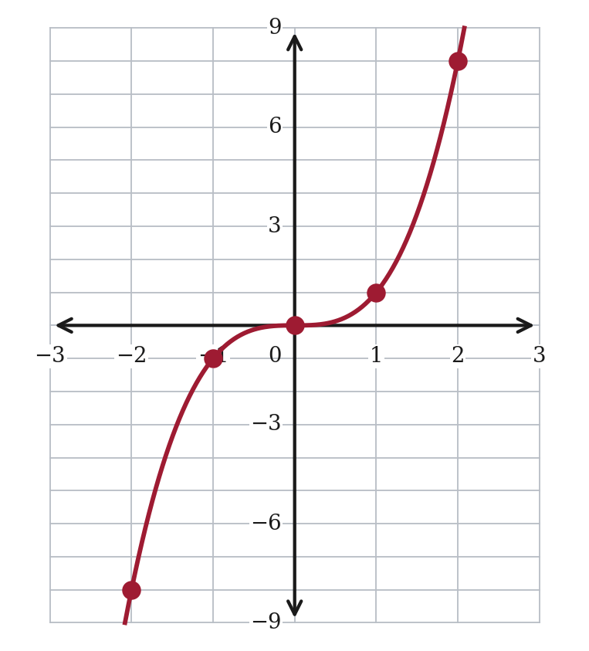
The graph passes through the origin and crosses the x-axis there. The graph of y = x² touches the x-axis at the origin and turns back up.
13. The equation x² = 36 has two solutions, but the equation x³ = 27 has only one. Explain why.
x² = 36 has two solutions because 6 × 6 = 36 and (−6) × (−6) = 36.
x³ = 27 has one solution because 3 × 3 × 3 = 27, but (−3) × (−3) × (−3) = −27.
Two negative factors give a positive; three give a negative.
The point needs the count of negative factors.
STRETCH. The two questions below use cubes larger than the Grade 8 FAST will ask for. The method is identical — only the arithmetic is bigger.
14. 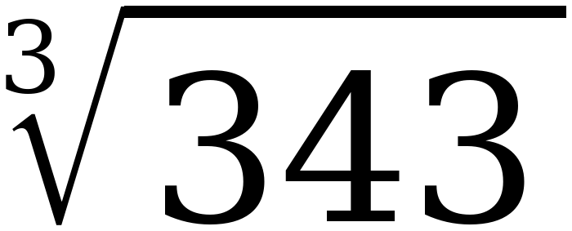
7 7 × 7 × 7 = 343

15. m³ = 512
m = 8 8 × 8 × 8 = 512
Still one solution.

